Exercise 1 – Preparing the Data Files
I used Python in Google Colab to prepare and inspect the mn.csv and mn_headers.csv files required for the data-wrangling activity. I imported the datasets using Pandas and checked their dimensions and first five records. The mn.csv dataset contained 9,080 rows and 159 columns, while mn_headers.csv contained 209 rows and three columns. The main dataset uses abbreviated variable names, while the header dataset provides more understandable descriptions of these variables, such as HH1 for "Cluster number" and HH2 for "Household number".
Inspecting the data also highlighted potential data-quality issues, including missing values (NaN) and columns containing mixed data types. This demonstrated why initial data inspection is important before cleaning and analysing a dataset. It also helped me understand how metadata can be used to interpret variables that would otherwise be difficult to understand.
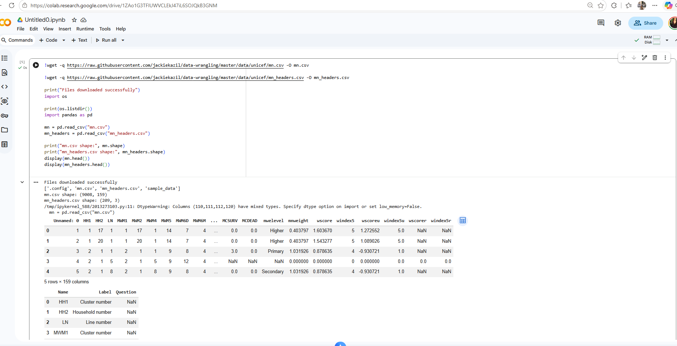

Exercise 2 – Replacing Headers with Readable Labels
In this exercise, I focused on making the dataset easier to understand by replacing the abbreviated column headings in mn.csv with more meaningful descriptions from mn_headers.csv. I created a mapping between the variable names and their corresponding labels and used Python to compare these with the 159 columns in the main dataset.
The results showed that 150 of the 159 headers were successfully matched, leaving nine unmatched headers. This highlighted an issue that can occur when working with data and metadata obtained from different sources, as the available descriptions may not always correspond exactly with every variable in the dataset. Rather than automatically removing the unmatched columns, I retained their original names so that they could be investigated further before deciding whether the data should be excluded.
I then replaced the successfully matched abbreviations with their more descriptive labels. For example, HH1 was changed to “Cluster number”, HH2 to “Household number”, and LN to “Line number”. Comparing the original and updated headings demonstrated how much easier the dataset was to interpret after this transformation.
This exercise helped me understand how Python can be used to automate the process of matching and transforming metadata, rather than manually renaming a large number of variables. It also reinforced the importance of checking the results of data transformations and investigating unmatched information rather than assuming that data from different sources will align correctly.
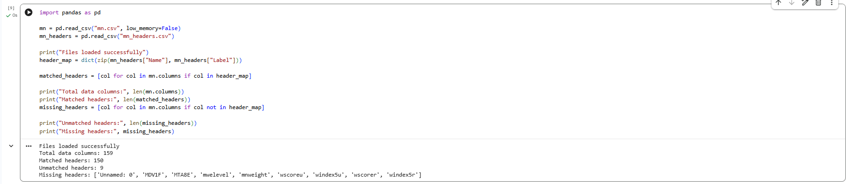

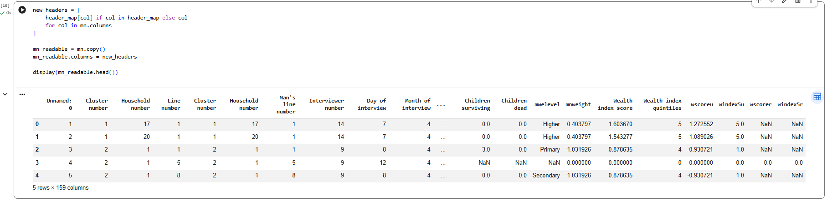

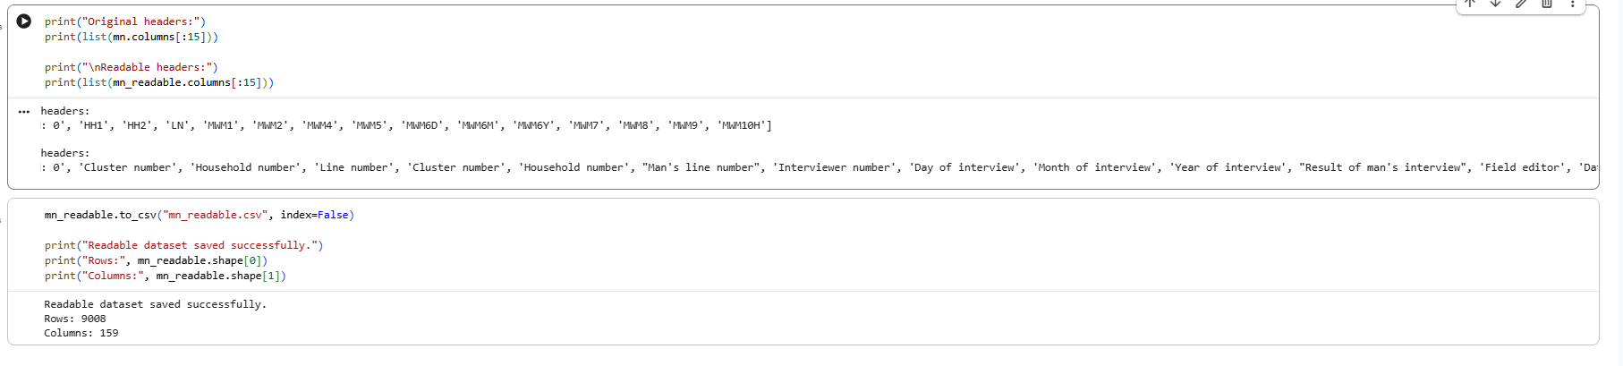

Exercise 3 – Formatting Data
In this exercise, I used Python to improve the presentation and readability of the survey data. Although the previous exercise replaced abbreviated headers with more meaningful labels, some of the information in the Question column of the header dataset contained missing (NaN) values. This meant that relying only on the survey questions would not provide a complete description of the data.
To address this, I created a readable description for each variable by using the full survey question where it was available and using the shorter label where the question was missing. I then matched these descriptions with the corresponding values from the first survey record and formatted the output so that each description appeared alongside its answer.
The resulting output was much easier to interpret, displaying information such as “Cluster number: 1”, “Year of interview: 2014” and “Result of man's interview: Completed”, rather than only showing abbreviated variable codes and values.
This exercise demonstrated how formatting can make raw data more understandable and highlighted the importance of handling missing metadata appropriately. It also showed how Python can be used to combine different pieces of information and present data in a clearer format for subsequent analysis.

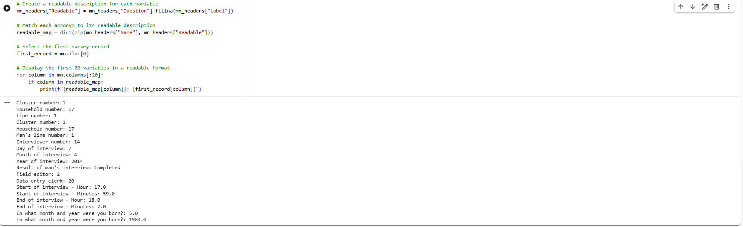

Exercises 4 and 5 – Examining Data Values and Data Types
In this exercise, I examined the values within the UNICEF survey dataset to identify non-applicable (NA) responses and consider how these should be handled during data cleaning. The dataset contained 9,008 records, and the analysis showed that every record contained at least one NA response. When individual values across the dataset were counted, NA occurred 606,612 times, making it the most frequently occurring value.
The large number of NA responses highlighted the importance of understanding the context of the data before removing records. In a survey, an NA response may indicate that a particular question was not applicable to a respondent rather than representing an error. Therefore, automatically deleting records containing NA values could result in the unnecessary loss of valid information.
I also examined the distribution of data types across the 159 columns. The results showed that 142 columns were classified as objects, 15 as integers (int64) and two as floating-point numbers (float64). The high number of object columns may partly reflect the presence of text responses such as NA, which can cause columns containing otherwise numerical information to be interpreted as text.
Overall, this activity demonstrated the importance of examining both values and data types before cleaning a dataset. Missing or non-applicable responses should be investigated before deciding whether to remove them, while checking data types can help identify variables that may require conversion or further cleaning before statistical analysis.
